Министерство образования и науки РД
ГПОБУ РД «Дербентский профессионально – педагогический колледж им. Г.Б. Казиахмедова»
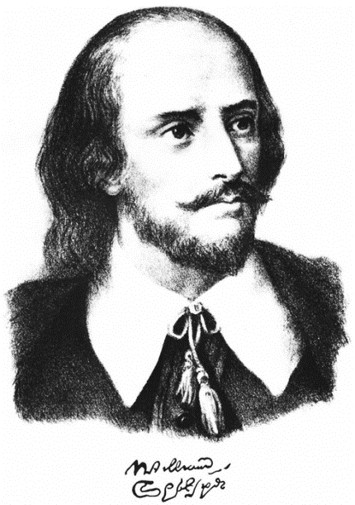

Внеклассное мероприятие
на тему:
«Любовь и Шекспир»

Ответственная:
Гаджимагомедова Л.С.

Дербент, 2018
Teacher: Good afternoon, dear guests! We are glad to see you at our performance today. The students of the 4 B have prepared it especially for you. Take your places and enjoy, please.

Poet is sitting at the table with pen in his hand and writing poems. He cannot do it. He is nervous because of it. Suddenly The Love is appeared.
L: Stop.
P: Who are you? I want to see nobody today.
L: I am the Love and I want to help you.
P: Oh, my God. How can you help me? What can you do for me?
L: You are wrong. I can help you. I know why you can’t create.
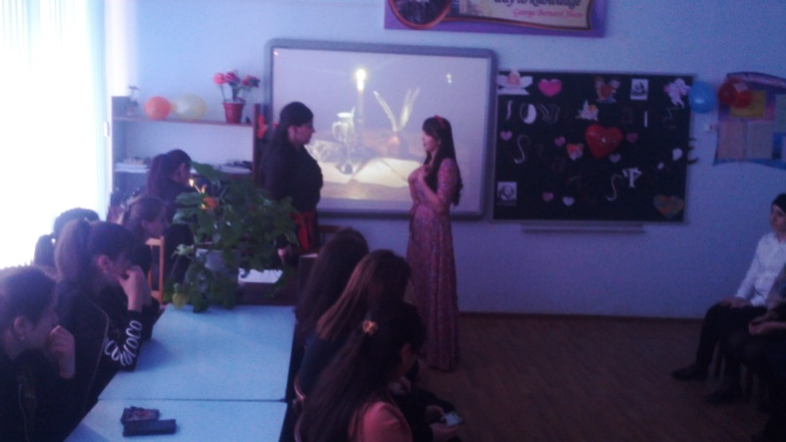
P: Why? What do you know about me?
L: You don’t believe in Love and you can’t do it. But you should know that only the love moves peoples, souls and poets pens.
P: It is nonsense. I am just out of spirit today and I don’t want to listen to your old speech that Love is forever and not repeated.
L: Don’t you believe me? Take your place and look attentively. I will show you the Real Love.
(сцена «на балконе» из произведения «Ромео и Джульетта»)

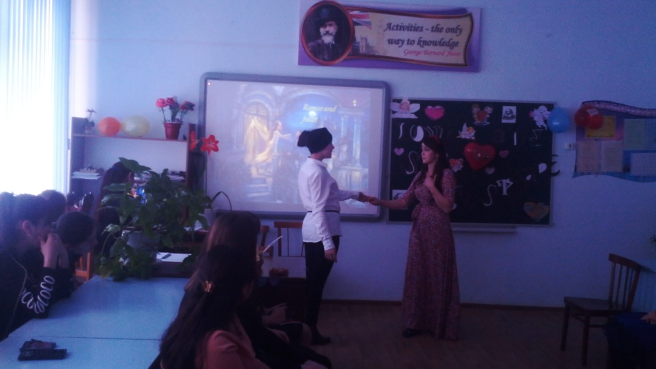
Juliet. O Romeo, Romeo! Why are you Romeo?
Deny your father and refuse your name.
Oh, if you will not, be but sworn my love
And I’ll no longer be a Capulet!
Romeo. Shall I hear more, or shall I speak at this?
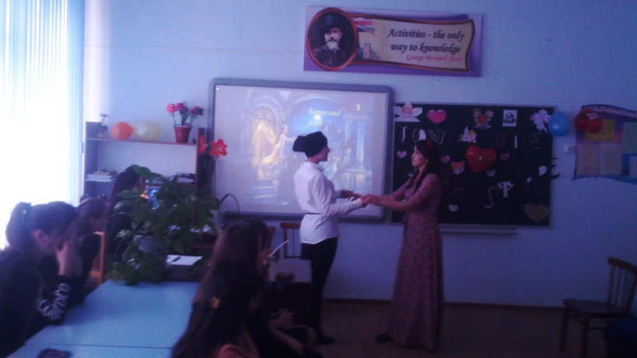
Juliet. “Tis but your name that is my enemy;
What’s Montague? It’s nor hand, nor foot,
No arm, nor face, nor any other part
Belonging to a man. Oh, be some other name!
Romeo. I take you at your word.
Call me but love, and I’ll be new baptized;
And since then I never will be Romeo.
Juliet. Do you love me? I know you’ll say yes and I will take your word.
Romeo. Lady, by yonder blessed moon I swear…
Juliet. O! Swear not by the moon, the inconstant moon
That monthly changes in her circled orb.
Lest that your love.
Romeo. What shall I swear by?
Juliet. Don’t swear at all.
Good night, good night, my Romeo!

Кizil: I think you guess that the topic of our performance today is LOVE…..
Albina M: We want to ask you. What is Love? Who can we love?
Kizil: I think we can love a lot. Look at the screen and you will understand everything…

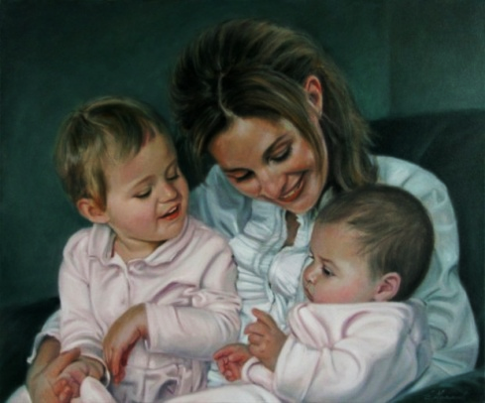
Mother love their child
People love their country
Men love women
Albina M: There is a box with hearts of paper. I want you to take it and read what Love is…
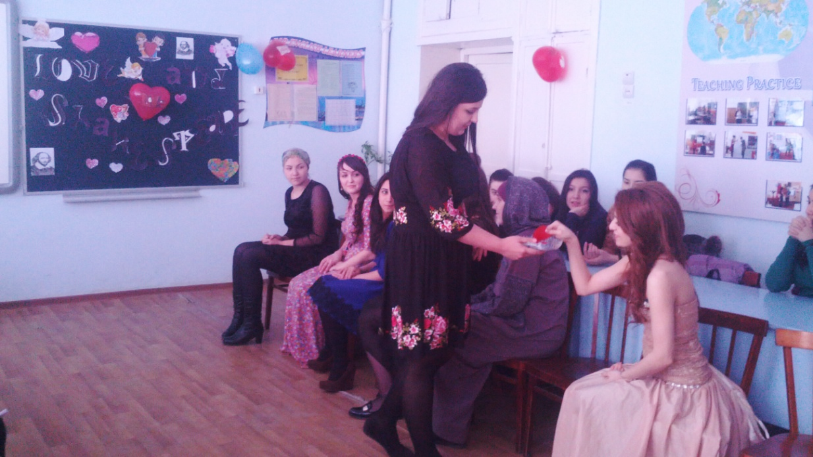
Now it is time to hear what teachers of our college think about this meaning
(видеорепортаж)
Kizil: It is wonder, but the word Love is understood without translation in all languages of the world. You can meet this topic everywhere in literature, art, music, cinema. It is always new and not repeated for everyone.

(на экране надписи «я тебя люблю» на всех языка)
Game
Kizil: Let’s play a little. I need three volunteers. Come to me, please. Take pencils and a sheet of paper. Your task is to draw what you love best of all and explain it.
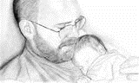
Unfortunately, sometimes loving each other people can make mistakes in their relations because of jealousy. And such relations are usually finished with unhappy end. One of these examples, we are going to show you.
Отелло: Have you prayed, my darling, yet?

Дездемона:
Oh, yes, my Lord. But why?
What’s wrong with you?
Why are you so pale?

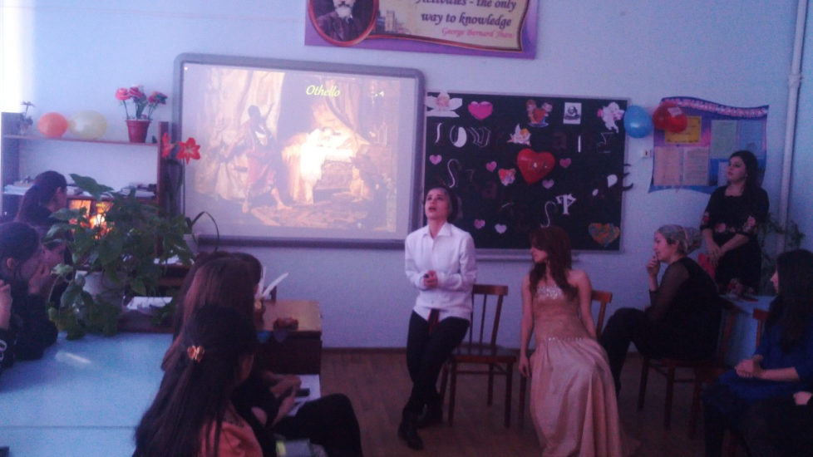
Отелло: You have deceived me. Now you must die.
Дездемона:
What for? I love you so much.
I didn’t bring you any harm, believe me.
Отелло: I wish I could believe.
(Дездемона пытается вырваться)
No, you must die.

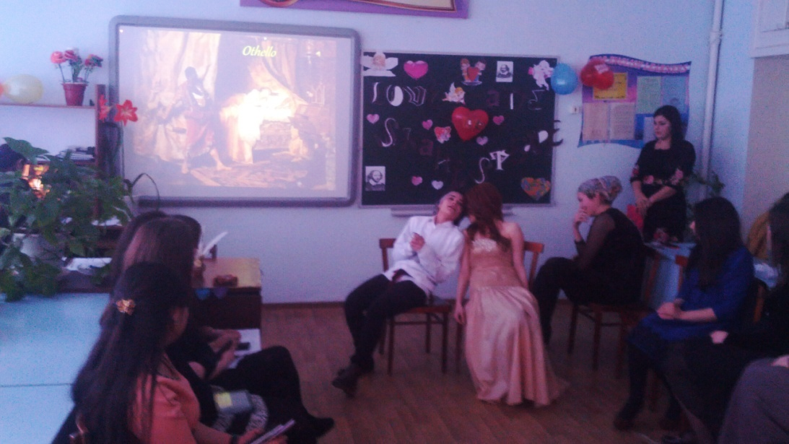
(Отелло душит Дездемону. Дездемона умирает).
Albina M: When we speak about Love we can’t keep from mentioning of William Shakespeare. He was one of the greatest and famous writers in human history. He was born in Stratford-on-Avon, a small town in the middle of England. His father wanted his son to be a well-educated person and William was sent to the local grammar school.

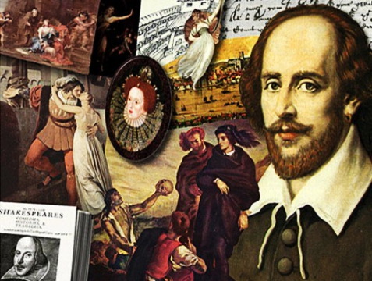
Kizil: He went to London and there he became an actor. At that time he began to write plays too. Shakespeare was at the same time an actor and a playwright. In his works he reflected events of his contemporaries' life. His plays were staged in many theatres, translated into many foreign languages. That made Shakespeare a very popular man. Most famous of his plays are Othello, King Lear, Hamlet, and Romeo and Juliet. They are still popular and you can watch his .plays in almost any country of the world. 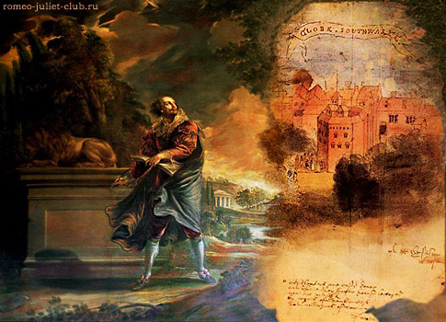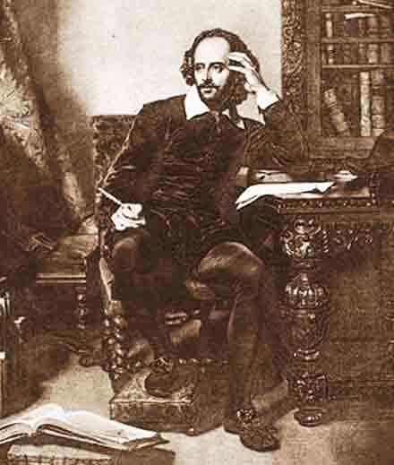
Albina M: Oh, what is it? It is a letter. Sophia is writing….(ведущая зачитывает письмо девушки, которая признается в неверности). Kizil, what can you advice to this girl.
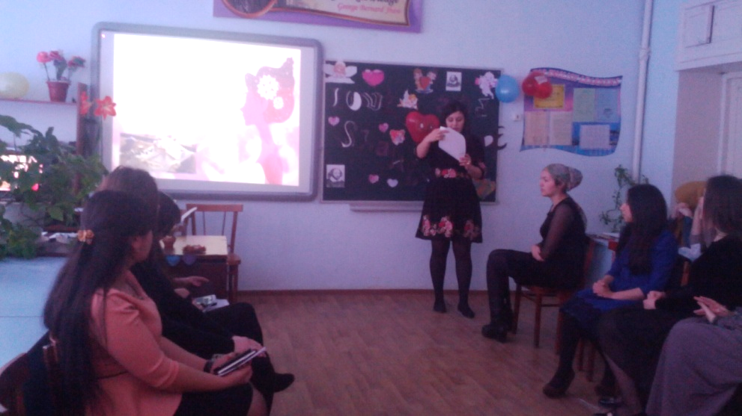
Kizil: I think, this girl must be with that boy who is loved by her.
Albina: Dear guests, what you think about this problem. Give our pieces of advice. (каждый высказывает свое мнение). Kizil, I think our spectators are tired a little. Let’s listen to the song.
(звучит песня о любви в исполнении студентки)
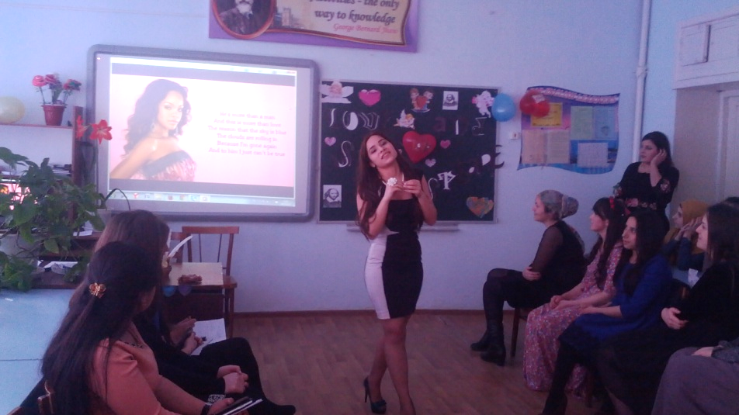
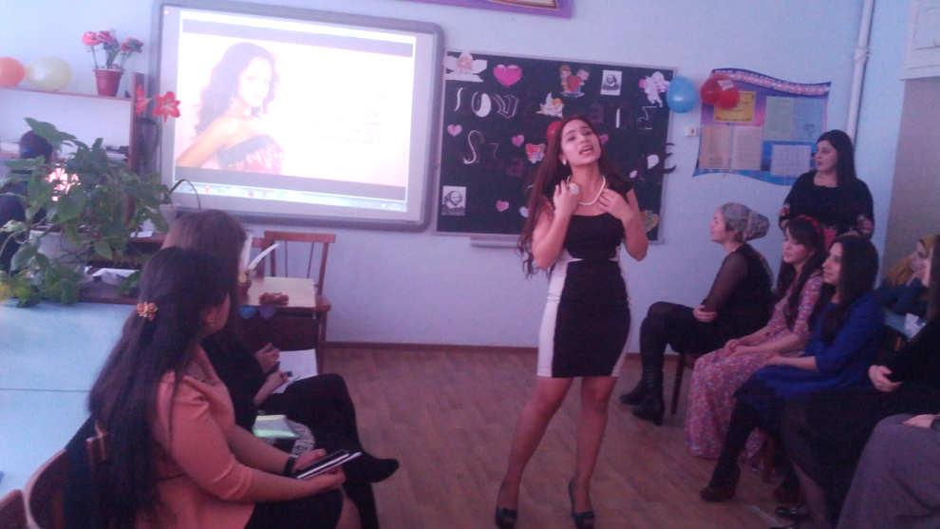

Kizil: Stratford –upon –Avon is very famous town. There are no mountains there, but there are beautiful woods, green fields and quiet river – the Avon. Every year four million tourists visit this place. They usually come to the well-known Royal Shakespeare Theatre – one of the biggest theatres in Britain.
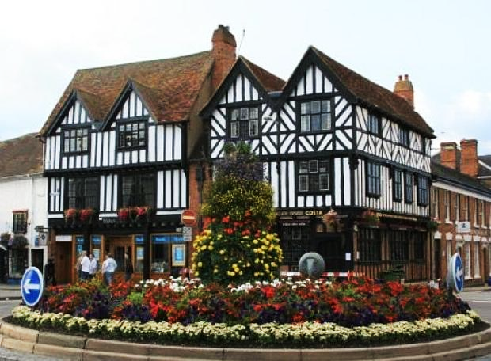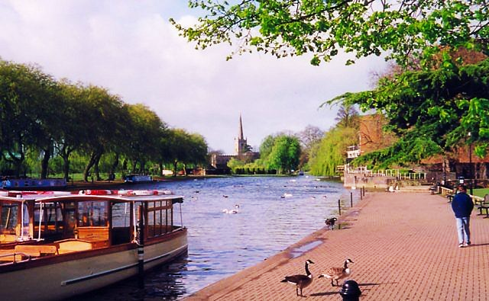
(видео о городе, где родился В.Шекспир).
Albina M: It must be admitted that British people are very proud of their great poet and call him “Our national Bard’, “The immortal Poet”. He is beloved by Russian people. His plays are staged in Russian theatres too.
(разыгрывается сценка из трагедии Шекспира «Король Лир»)
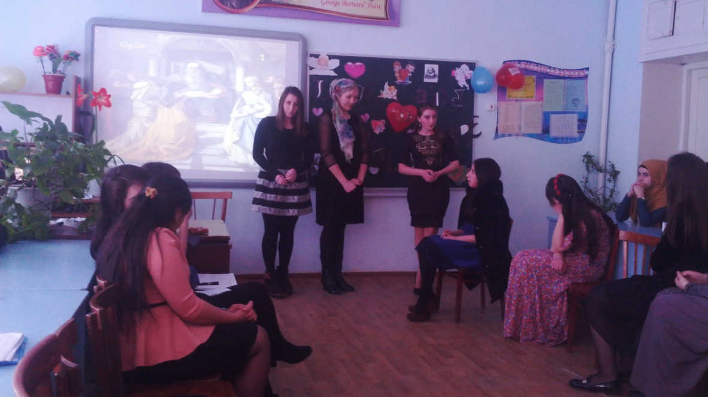
King Lear: My dear daughters, I’m very old and tired. I can’t be the King of Britain any more. I want to divide the country into three parts and give one part to each of you. And you’ll be the queens of your parts. But first you must tell me how much you love me. Then I will know which of you must get the better part.
Goneril: Dear father, I love you very much. I love you more than my beauty, more than my life. No child loves his father more than I do.
Regan: If only you knew what you mean for me. You are the dearest man in my life. I can’t imagine myself without you.
King Lear: I’m very glad to hear that. And what would you like to tell me, Cordelia?
Cordelia: I don’t understand why my sisters say they love you more than anything else. They are married. Don’t they love their husbands? You are my father, and of course, I love you. But when I marry I’ll love my husband, too.
King Lear: Oh, it’s not the right thing you’ve told me! I’m disappointed. I don’t want to have such a daughter! You’ll get nothing! Go away!
Kizil: Well, dear guests! Have you recognized the play? Certainly, it’s “King Lear”.
William Shakespeare wrote also a lot of poetry including his unbeaten sonnets. There are numerous songs written with his poems. He is still most often published author of the world and well known among people.
(студентка декламирует сонету В.Шекспира “My mistress, eyes….”)
My mistress' eyes are nothing like the sun;
Coral is far more red, than her lips red:
If snow be white, why then her breasts are dun;
If hairs be wires, black wires grow on her head.
I have seen roses damask'd, red and white,
But no such roses see I in her cheeks;
And in some perfumes is there more delight
Than in the breath that from my mistress reeks.
I love to hear her speak, yet well I know
That music hath a far more pleasing sound:
I grant I never saw a goddess go,--
My mistress, when she walks, treads on the ground:
And yet by heaven, I think my love as rare,
As any she belied with false compare.
Albina: Let’s have a fun. There are three different colored balloons. There is task in it. You must do this task.
Task 1. Complete the sentence…..
Task 2. Read the Parable about Love….

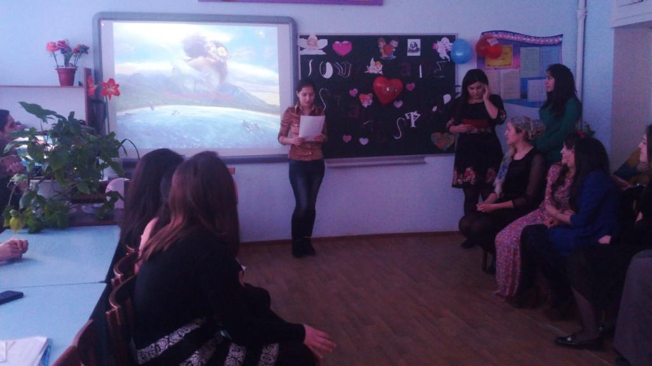
Task 3. Match the beginnings and the endings…
Now I think it is time to finish our performance, but before doing it I want to ask everybody to declare of love and say to each other beautiful words. Begin with me: “Dear Albina, I love you because you are very kind girl”. Go on, please.
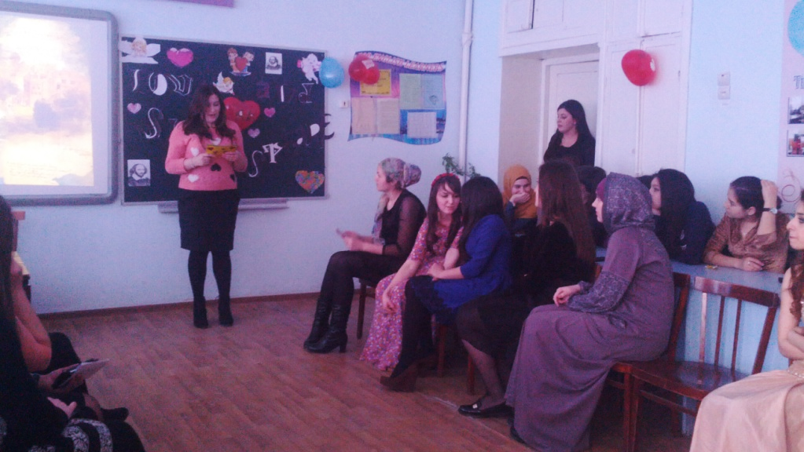
(каждый по цепочке продолжает признаваться в любви).
(после этого видеоистория о любви)
Teacher: Dear guests, I want every woman in the world to be happy, to have a lovely home, to have beautiful babies and to be loved by her husband. Thank you for attention. Good Luck!
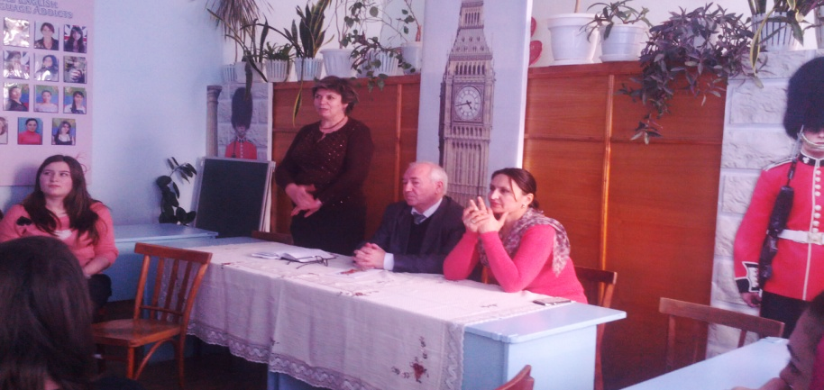
Целеполагание для учителя:
- Формировать лингвострановедческую компетенцию учащихся путем ознакомления с английской литературой и наследием страны изучаемого языка.
- Познакомить учащихся со страницами жизни и творчества У.Шекспира, внесшего большой вклад в литературный процесс и развитие поэзии Англии.
- Помочь учащимся в освоении новых лексических единиц английского языка.
- Воспитывать интерес к английскому языку и культуре страны изучаемого языка.
- На примере лирики и отрывков из трагедии «Ромео и Джульетта», «Отелло», «Король лир» воспитывать эмоциональную и интеллектуальную отзывчивость.
Цели для учащихся:
- Знать краткие сведения о личности У.Шекспира, об истоках его творчества.
- Уметь выразительно читать стихотворения, показывая личное отношение к поэту и его творчеству.
- Уметь инсценировать отрывки из трагедии Шекспира, выражая своё отношение к героям и их поступкам.
Задачи:
- Уебные:
  - обучение рецептивным видам речевой деятельности;
  - формирование способности участвовать в непосредственном и опосредованном диалоге культур;
  - формирование и развитие коммуникативных умений учащихся на основе языковых, лингвострановедческих и социокультурных знаний, навыков: умения воспринимать на слух и понимать краткие сообщения.

- Познавательные:
  - расширение эрудиции учащихся, их лингвистического, филологического и общего кругозора.
- Развивающие:
  - интеллектуальное развитие учащихся;
  - развитие языковых, интеллектуальных и познавательных способностей, ценностных ориентаций, чувств и эмоций студента, готовность к коммуникации;
  - гуманитарное и гуманистическое развитие личности студента.
- Воспитательные:
  - формирование у учащихся уважения и интереса к культуре и народу страны изучаемого языка;
  - воспитание культуры общения;
  - воспитание интереса к учению и формирование познавательной активности;
  - формирование потребности в практическом использовании языка в различных сферах деятельности.
Оборудование:
портрет У.Шекспира, стенгазеты, посвященные его творчеству, плакаты с известными крылатыми выражениями и фразеологизмами, принадлежащими Шекспиру.
Место проведения:
данное мероприятие проводится в дни декады "Иностранный язык". Учащиеся получили задания: подготовить краткие сообщения о поэте, выучить стихи и отрывки из трагедии и подготовиться к выразительному чтению, подготовить сообщение и сделать презентацию о театре "Глобус", о городе , где родился великий поэт, оформить стенгазеты и написать высказывания Шекспира. В процессе подготовки к мероприятию были отобраны ведущие, актеры заучивали свои роли, отрабатывали произношение. Особое внимание было уделено оформлению зала и музыкальному сопровождению мероприятия.
Виды читательской деятельности:
сообщения о поэте, городе, где он родился и его театре, выразительное чтение, инсценирование.

